VISVESVARAYA TECHNOLOGICAL UNIVERSITY
“Jnana Sangama”, Belagavi-18, Karnataka, India.


Synopsis on

Interdisciplinary Project Based Learning (1BPRJ208)

“River Flood Detection System”

Submitted in partial fulfillment of the requirement for the degree of

Bachelor of Engineering
By

Student Name | USN | Department
Purujith Kadekar | 1DS25ET087 | Electronics & Telecommunication
Pranav Verma | 1DS25ET084 | Electronics & Telecommunication
Roshani Kumari | 1DS25CS212 | Computer Science
Rupesh Kumar S | 1DS25CS213 | Computer Science

2nd Sem B.E
Under the guidance of
Dr. Preeti Khanwalkar
Assistant Professor



Department of Electronics and Telecommunication Engineering
DAYANANDA SAGAR COLLEGE OF ENGINEERING BENGALURU -560078
2025-26

ABSTRACT :
Floods are a major threat to lives and property, often occurring so quickly that traditional monitoring methods fail to provide enough warning. Currently, most systems rely on manual checks or expensive infrastructure that doesn't work well in remote areas. This project solves that problem by creating an affordable, solar-powered "smart" monitoring system that can be placed directly on riverbanks. The system uses a wireless sensor node that measures water levels in real-time. Because it is solar-powered, it can run indefinitely without anyone needing to change the batteries. When the water rises to a dangerous level, the system immediately sounds a loud local alarm to warn people nearby. At the same time, it uses long-range radio technology to send this data to a central gateway, even in areas where there is no mobile phone signal. The final result is a reliable early-warning system that saves data to a secure database and displays it on a live website. To ensure critical warnings reach users even without internet access, the system integrates the TextBee REST API as an SMS gateway, enabling the Raspberry Pi to dispatch emergency text alerts through a connected device’s native cellular hardware without requiring a dedicated GSM module or cloud SMS subscription. This allows authorities and the public to monitor river levels from any device, while receiving direct text alerts during emergencies.

OBJECTIVES :
- To design and deploy a self-contained, battery-powered edge node using the ESP32-S3 microcontroller that continuously monitors river water levels via an ultrasonic sensor [1][2] and delivers an immediate local acoustic alert when a critical flood threshold is breached.
- To implement a reliable long-range wireless telemetry link using LoRa module[4][5] that transmits structured sensor payloads including water level distance, RSSI, and timestamp to a Raspberry Pi Zero 2W gateway every five seconds, independent of cellular or internet infrastructure.
- To develop a Python backend on the Raspberry Pi Zero 2W that receives LoRa packets, applies a 2-minute temporal verification algorithm to suppress false alarms, persists time-series readings in a local SQLite database [3], serves a real-time web dashboard via Flask, and dispatches emergency SMS alerts through the TextBee REST API upon confirmed flood detection

LITERATURE SURVEY :
The current state of flood monitoring technology was analyzed through a comprehensive review of existing research. The findings, summarized in Table 1.1, highlight the shift toward LoRa-based IoT systems while identifying gaps in local data persistence and self-hosted visualization.
Table 1.1: Summary of Literature Review on Flood Monitoring Systems
Sl.No | Author & year | Title | Method / Tools | Key results | Disadvantages / Gaps identified
 | M.I. Zakaria et al. (2023) | Development of a smart sensing unit for LoRaWAN-based IoT flood monitoring and warning system in catchment areas | HC-SR04 ultrasonic sensor + Arduino + LoRaWAN gateway; TagoIO & ThingSpeak cloud; solar-powered standalone node | Achieved four-level alert classification (safe/alert/cautious/dangerous); evaluated RSSI & SNR for SF7 and SF12; PDR and delay benchmarked across two spreading factors | Uses Arduino Uno with limited RAM; no local edge-side database; cloud-dependent dashboard increases latency for offline environments
 | P. Yoeseph et al. (2022) | LoRa-based IoT sensor node for Real-time Flood Early Warning System | Ultrasonic sensor HY-SRF05 + water flow meter YF-S201 + BsFrance LoRa32u4 II module; open-source IoT platform for visualization | Ultrasonic sensor accuracy: 97.06%; water flow sensor accuracy: 91.96%; latency measured as time between sensor reading and database record | Single-node design; no gateway redundancy; no local data persistence on the node; limited to LoS deployment
 | N. A. Alias et al. (2025) | Real-time Flood Monitoring Alert System with LoRa and IoT | ESP32 + ultrasonic sensor + AHT20+BMP280 + LoRa; ThingSpeak cloud dashboard; OLED local display | Multi-parameter monitoring (water level, flow, temp, humidity); data displayed on OLED and ThingSpeak; tested across different campus locations | ThingSpeak data loss observed at certain locations; no local SQLite logging; web dashboard not self-hosted; no RSSI logging for link quality diagnostics
 | P. Singh et al. (2024) | Experimental analysis of low-duty cycle campus-deployed IoT network using LoRa technology | SX1278 LoRa module at 433 MHz; systematic measurement of RSSI, SNR, PRR across LoS and NLoS scenarios at university campus | LoS with SF=9, CR=4/5: RSSI = -89.12 dBm, SNR = 9.91 dB; performance highly sensitive to SF and CR parameter tuning | Focuses only on link-level RF performance; no end-to-end application or data logging stack evaluated; no flood-specific use case

Key findings from the literature survey:
The reviewed literature provides a comprehensive technical foundation for this project across four key areas:
- Sensor Reliability: Studies by Zakaria et al. and Yoeseph et al. confirm that ultrasonic sensors provide over 97% accuracy in water-level detection [1][2], making them a standard for non-contact river monitoring.
- Alert Classification: Zakaria et al. demonstrated the effectiveness of a four-level alert system (Safe to Dangerous) [1], which this project adopts for its local buzzer and remote SMS logic.
- Connectivity Performance: Singh et al. provided critical RF benchmarks [5], showing that LoRa at 433 MHz maintains stable Signal-to-Noise Ratio (SNR) and RSSI even in campus-like environments with obstructions, justifying the use of the Ra-02 module for remote riverbanks.
- Architectural Gaps: While Alias et al. utilized ESP32 for multi-parameter sensing [3], their reliance on cloud platforms like ThingSpeak often leads to data loss during internet outages. This project addresses this by implementing a local SQLite database on a Raspberry Pi gateway.

METHODOLOGY :

4.1 System Architecture Overview
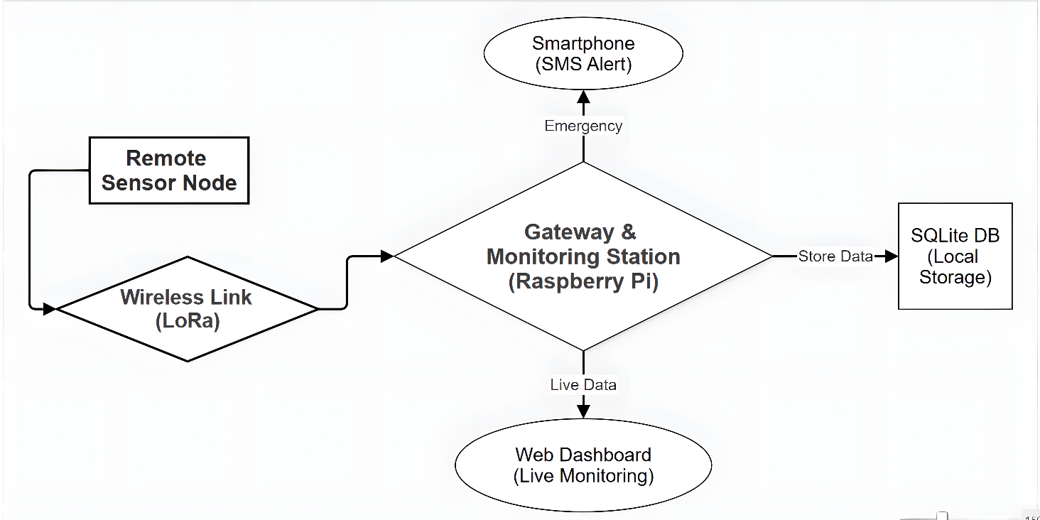
The system follows a Hybrid LoRa-to-Cloud architecture. As illustrated in the block diagram in Fig. 1.1, the edge node (ESP32-S3) transmits water level data to the gateway (Raspberry Pi Zero 2W) via LoRa. The gateway stores this in an SQLite database and hosts a web dashboard. For emergency notifications, the system integrates the TextBee REST API, which enables the Raspberry Pi to trigger SMS dispatch through a TextBee-enrolled device’s native cellular messaging hardware without requiring a dedicated GSM module or cloud SMS subscription.

Fig. 1.1: System Architecture and Data Flow Diagram

4.2 Edge Node Firmware Logic (ESP32-S3)
The operational logic of the remote sensing unit is detailed in the flowchart shown in Fig. 1.2.
• Firmware written in C++ using Arduino IDE with the LoRa library.
• Distance calculation: d = (t_echo × 343 m/s) / 2.
• If distance >800cm (flood threshold), GPIO 7 drives the piezo at 2 kHz.
• Every 5 seconds: distance value is packaged and transmitted via Ra-02 LoRa.
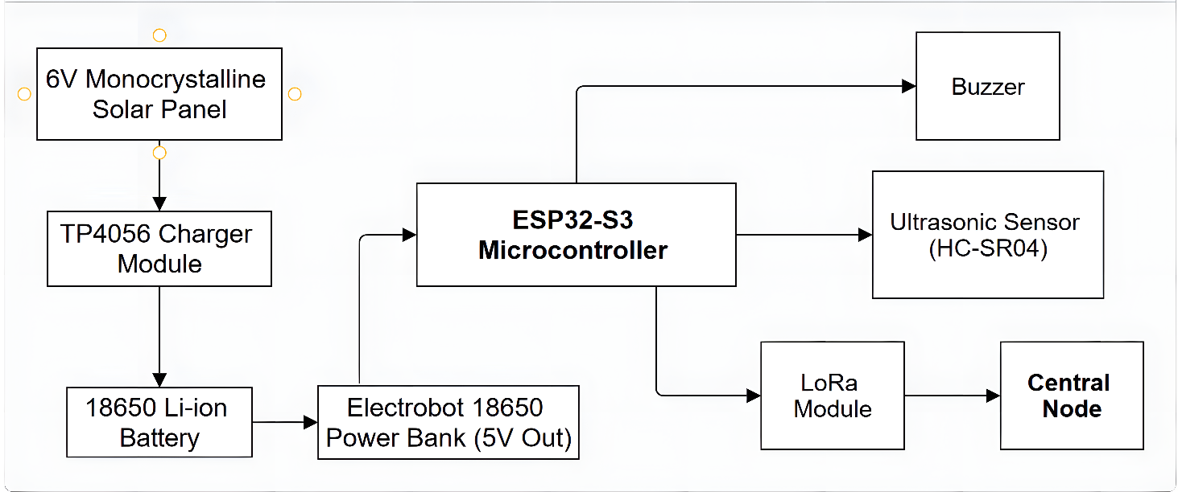
Fig. 1.2: Edge Node Sensing and Alerting Logic Flowchart

4.3 Central Node Software (Raspberry Pi Zero 2W)
The gateway manages data processing and user alerts as depicted in the software process flow in Fig. 1.3.
- A background thread polls the Ra-02 (connected via SPI GPIO pins) for incoming packets.
- A separate database-writer thread drains the queue and writes to SQLite via SQLAlchemy.
- An alert-check logic monitors incoming data using a Temporal Verification Rule: a 24-sample circular buffer at 5-second intervals (2-minute window) is maintained, and a "Confirmed Flood" is only declared when 90% or more of those 24 readings breach the flood threshold. Upon confirmation, the Python script issues an HTTP POST request to the TextBee REST API, which triggers SMS alert dispatch through the TextBee-enrolled device’s native cellular messaging hardware. A rapid-rise detector additionally flags events where water rises faster than 2 cm/min, distinguishing flash floods from transient noise. Flask serves a dashboard consuming data via Chart.js for real-time visualization.

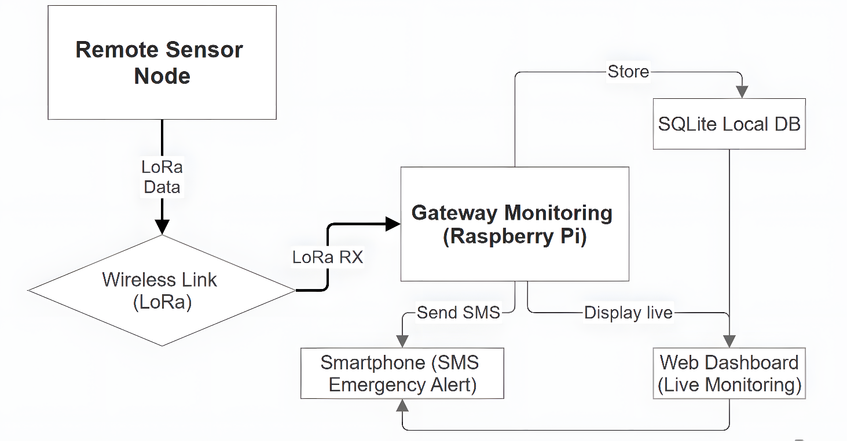
Fig. 1.3: Central Node Software and SMS Trigger Logic

4.4 Components and Specifications

The hardware selection for the system was based on power efficiency and long-range communication capabilities. Detailed specifications are provided in Table 1.2, followed by individual component descriptions and visual references.

Table 1.2: Hardware Components and Technical Specifications
Component | Model / Part | Specification | Role in System
Microcontroller | ESP32-S3-WROOM-N16R8 (Edgehax S3-Pro) | Xtensa LX7 dual-core, 240 MHz; 16 MB Flash; 8 MB PSRAM; 3.3 V I/O; Wi-Fi + BT 5.0 | Edge sensing, data processing, LoRa control, PWM buzzer drive
Ultrasonic Sensor | HC-SR04 (3.3 V mod) | Range: 2 cm – 400 cm; Resolution: ~3 mm; Frequency: 40 kHz; Operating: 3.3 V | Non-contact water surface distance measurement
LoRa Transceiver (Edge and Gateway) | Ai-Thinker Ra-02 (SX1278) | 433 MHz; Sensitivity: -148 dBm; TX Power: +18 dBm; SPI interface; LoRa spread-spectrum | Wireless transmission of distance + RSSI data to gateway
Central Node | Raspberry Pi Zero 2W | ARM Cortex-A53 quad-core 1 GHz; 512 MB RAM; 2.4 GHz Wi-Fi; GPIO 40-pin; 5 V/2 A | Flask web server, SQLAlchemy ORM, SQLite DB, dashboard
SMS Gateway | TextBee App | TextBee app installed on a TextBee-enrolled device; connected to Pi gateway via REST API over local Wi-Fi/internet | Receives API call from Pi during confirmed flood; dispatches SMS through the TextBee-enrolled device’s native cellular messaging hardware
Piezo Buzzer | Passive Piezo (generic) | Operating voltage: 3.3 V; Frequency range: 100 Hz – 6 kHz; Driven via PWM (GPIO 7) | Immediate local acoustic alert on flood threshold breach
Power System | Electrobot 18650 Power Bank Module | Input: 3.7V Li-Ion 18650 cell; Output: Stable 5V rail (boost); 2.4 A max; Digital LCD SoC display | Boosts 3.7V 18650 Li-ion cell to stable 5V rail for edge node; keep-alive loop prevents auto-shutoff
Solar Panel | 6V Monocrystalline (6W) | Peak Voltage: 6V; Weatherproof; Monocrystalline cells | Primary energy harvester for off-grid power.
Charger Module | TP4056 with Protection | Linear charge management; 1A max; Over-charge / over-discharge protection; charges 3.7V 18650 Li-ion cell | Regulates solar voltage to safely charge the 18650 cell.
Battery | 18650 Li-ion Cell | Nominal voltage: 3.7V; Typical capacity: 2000–3500 mAh; Rechargeable via TP4056 | Primary energy storage; solar-charged via TP4056; powers edge node through Electrobot 18650 Module
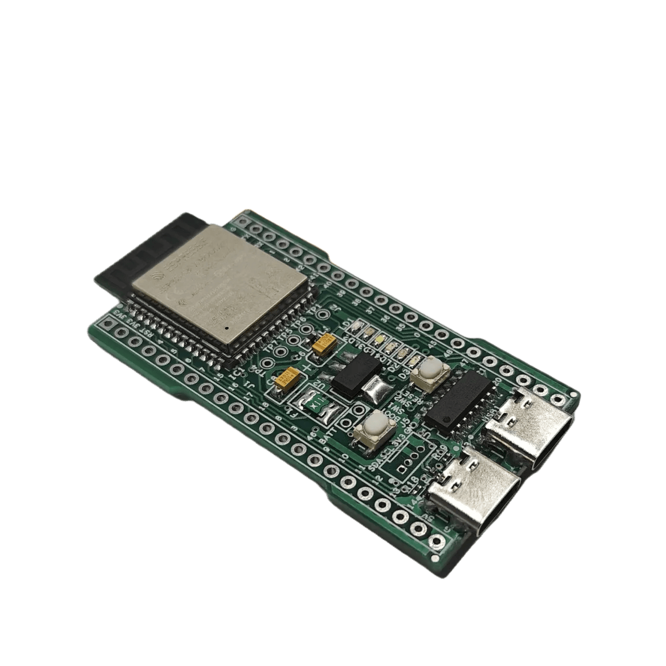
4.4.1 Component Descriptions:
- ESP32-S3 Microcontroller: As shown in Fig. 1.4, the ESP32-S3-WROOM-N16R8 provides dual-core processing power and high memory to handle sensor sampling and LoRa packet construction efficiently.
Fig 1.4: ESP32-S3-WROOM Microcontroller

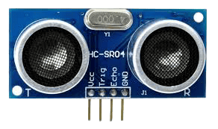
- HC-SR04 Ultrasonic Sensor: Detailed in Fig. 1.5, this sensor calculates the water level by emitting ultrasonic bursts. It is connected directly to the 3.3V supply to ensure compatibility with the microcontroller logic.
Fig. 1.5: HC-SR04 Ultrasonic Distance Sensor
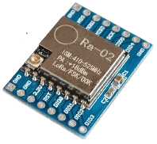
- Ai-Thinker Ra-02 LoRa Module: Illustrated in Fig. 1.6, this module uses Spread Spectrum communication to transmit data over long distances and is connected directly to the gateway GPIO pins.
Fig. 1.6: Ai-Thinker Ra-02 (SX1278) LoRa Module
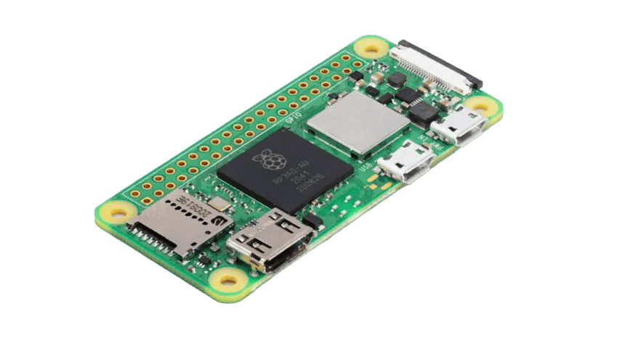

- Raspberry Pi Zero 2W: The central processing unit for the gateway, seen in Fig. 1.7, which runs the Python backend and hosts the local web dashboard.
Fig. 1.7: Raspberry Pi Zero 2W Gateway SBC

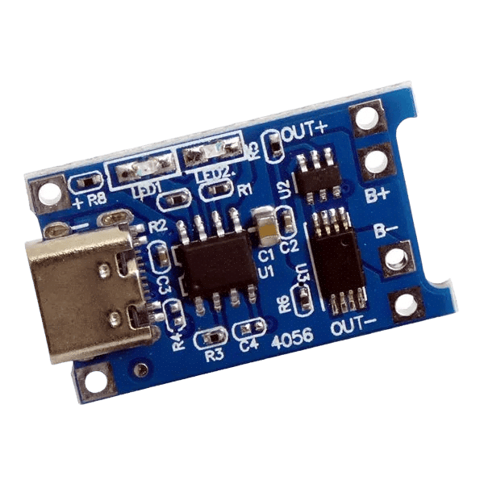
- Power Management System: This includes the Electrobot 18650 Module (Fig. 1.9) which boosts battery voltage and features an LCD for status monitoring, and the TP4056 Charger (Fig. 1.10) which manages solar charging.
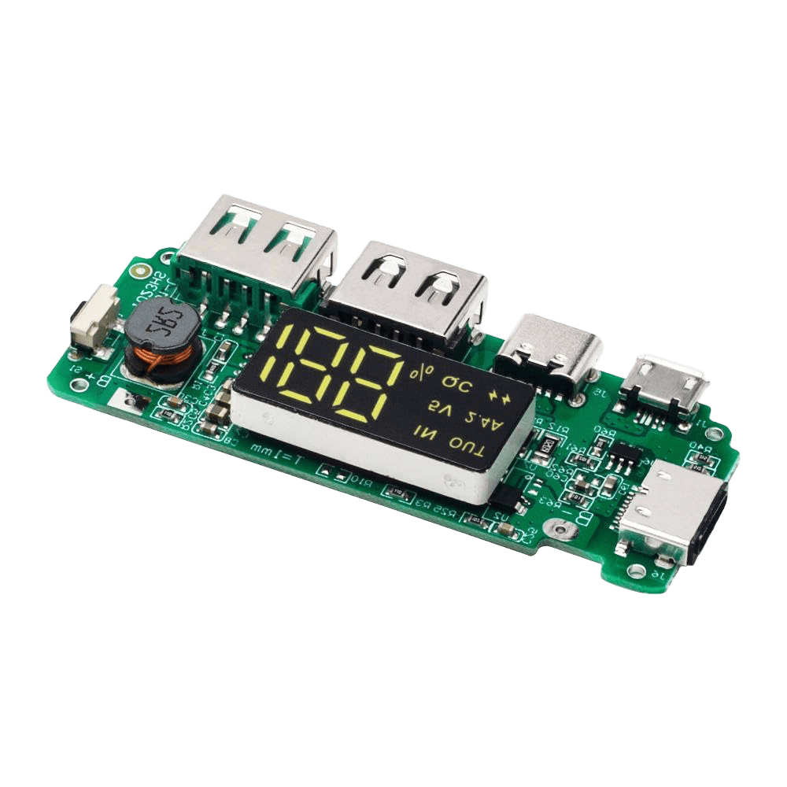

Fig. 1.10: Solar Charge Controller Module
Fig. 1.9: Power Bank Module with LCD Display

- Solar Panel and Battery: The 6V Monocrystalline panel (Fig. 1.11) and high-capacity 18650 Li-ion cell (Fig. 1.12) ensure the system remains powered 24/7 without external intervention.
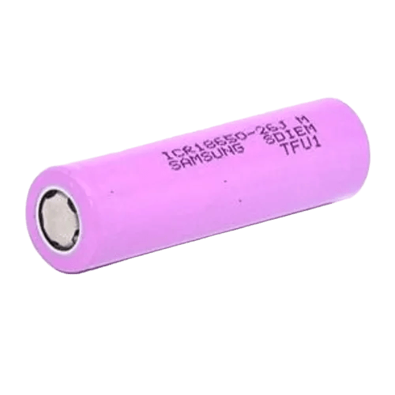
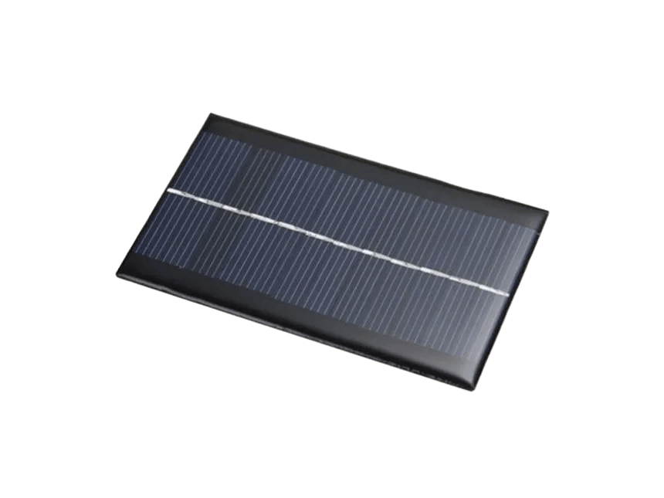

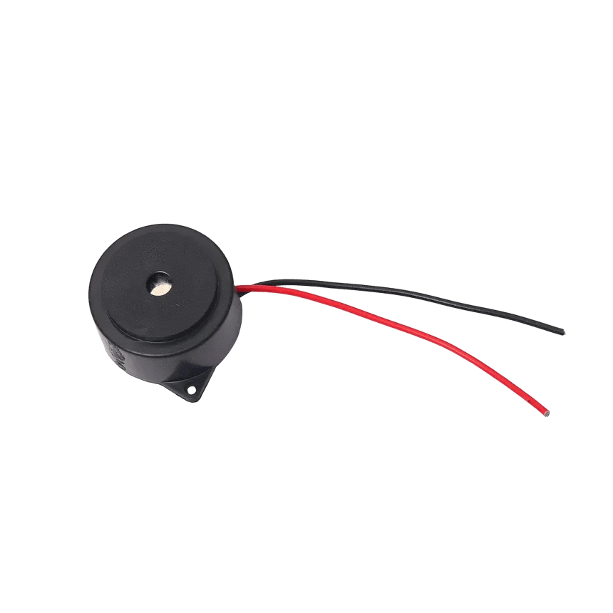
Fig. 1.11: 6V Monocrystalline Solar Panel
Fig. 1.12: 18650 Lithium-Ion Battery Cell

- Piezo Buzzer: Shown in Fig. 1.13, this provides a local audible warning at the river site, alerting anyone nearby of rising water levels.

Fig. 1.13: Passive Piezo Buzzer for Local Alerts

4.5 Software Tools and Technologies

The software architecture relies on open-source frameworks for data management and visualization, as summarized in Table 1.3.

Table 1.3: Software Tools and Development Environment
Tool / Library | Version / Platform | Purpose
Arduino IDE | v2.x (C++) | Firmware development for ESP32-S3 edge node
LoRa | Arduino library | SPI-level LoRa packet TX on Ra-02
Python 3.11 | Raspberry Pi Zero 2W | Gateway application runtime
Flask | 3.x (Python) | Lightweight REST API web server + HTML dashboard
SQLAlchemy ORM | 2.x (Python) | Object-relational mapping for SQLite database
TextBee API | REST HTTP (Python requests) | Sends HTTP POST from Pi gateway to the TextBee REST API to trigger SMS alerts on confirmed flood events via a TextBee-enrolled device
SQLite3 | Built-in | Lightweight file-based time-series database on Pi
spidev + RPi.GPIO | Python libraries | SPI communication with Ra-02 on Pi Zero 2W
Chart.js / Plotly | CDN (browser) | Frontend real-time line graphs of water level trends
threading / queue | Python stdlib | Concurrent LoRa receive thread + Flask web thread

PROJECT OUTCOMES :
- Solar-Powered, Infrastructure-Free Edge Sensing Node: Developed a self-powered river sensing unit built on the ESP32-S3 and HC-SR04 ultrasonic sensor that provides continuous, real-time water level measurements and triggers an immediate local piezo alarm upon breach of the 800 cm flood threshold, operating entirely without grid power or human intervention.
- LoRa-Based Long-Range Telemetry Independent of Cellular Networks: Successfully established a 433 MHz LoRa wireless link between the ESP32-S3 edge node and the Raspberry Pi Zero 2W gateway, transmitting structured sensor payloads every five seconds over several kilometres without dependence on mobile network infrastructure.
- Offline-Resilient Local Time-Series Data Persistence via SQLite: Implemented a thread-safe SQLite database on the Raspberry Pi gateway that logs every incoming water level reading with timestamp, ensuring complete historical data retention even during internet outages or cloud service failures.
- Smartphone-Based SMS Alert Dispatch via TextBee REST API: Eliminated the need for a dedicated GSM module by integrating TextBee, a third-party SMS API, which enables the Raspberry Pi to trigger emergency text alerts through a TextBee-enrolled device’s native cellular hardware at near-zero recurring cost.
- 24/7 Off-Grid Operation via Solar Harvest, TP4056 Charge Management, and 18650 Li-ion Storage: Designed a sustainable power system comprising a 6V monocrystalline solar panel, TP4056 charge controller, and 18650 Li-ion battery that maintains uninterrupted edge node operation in remote, off-grid riverbank deployments.
- 2-Minute Temporal Verification Algorithm to Suppress Transient False Flood Triggers: Implemented a 24-sample circular buffer sampled at 5-second intervals on the gateway, declaring a confirmed flood only when 90% of readings within the 2-minute window breach the threshold by filtering out false positives caused by rain splashes, floating debris, or momentary sensor noise.

CONCLUSION :
- This project demonstrates a viable, low-cost, and scalable solution for early flood detection in remote areas that lack reliable internet or grid power infrastructure. By combining LoRa-based long-range telemetry [5] with edge sensing on the ESP32-S3, the system achieves continuous, real-time river water level monitoring without dependence on cellular networks or cloud platforms [1][2].
- The system effectively bridges the gap between remote riverbanks and the people who need to stay safe. It successfully records every water level change and makes that information available on a live web dashboard and through direct SMS alerts dispatched via the TextBee REST API [3][4]. The 2-minute temporal verification algorithm ensures that confirmed flood events are distinguished from transient sensor noise, reducing the risk of false alarms in real-world deployments. The integration of a solar-powered subsystem with TP4056 charge management and 18650 Li-ion storage further ensures uninterrupted 24/7 operation in off-grid riverbank environments. Ultimately, this project offers a dependable, eco-friendly, and community-ready early warning system capable of protecting rural populations from the growing threat of natural flood disasters.

REFERENCES :

[1] M. I. Zakaria et al., "Development of a smart sensing unit for LoRaWAN-based IoT flood monitoring and warning system," Internet of Things and Cyber-Physical Systems, vol. 3, pp. 125-135, 2023, DOI: 10.1016/j.iotcps.2023.04.003.

[2] P. Yoeseph et al., "LoRa-based IoT sensor node for Real-time Flood Early Warning System," IOP Conference Series: Earth and Environmental Science, vol. 986, no. 1, p. 012060, 2022, DOI: 10.1088/1755-1315/986/1/012060.

[3] N. A. Alias et al., "Real-time flood monitoring alert system with LoRa and IoT," Evolution in Electrical and Electronic Engineering, vol. 6, no. 1, 2025.

[4] "LoRa technology for flood monitoring and warning system," Highlights in Ingenieria (HIJ), vol. 5, no. 4, 2024.

[5] P. Singh et al., "Experimental analysis of low-duty cycle campus-deployed IoT network using LoRa technology," Results in Engineering, vol. 21, p. 101783, 2024, DOI: 10.1016/j.rineng.2024.101783.

[6] D. Hercog et al., "A Low-Power LoRa-Based IoT Sensor Node for Flood Monitoring," Sensors, vol. 23, no. 15, 2023.

